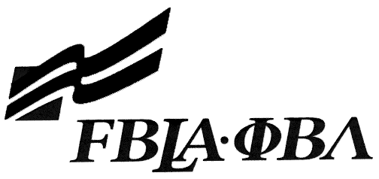 FBLA Statement of Assurance

District Event Entry Form

Digital Video Production

Provide the complete URL for Digital Video Production. This event will be judged online. Make sure the URL link is valid through the District Leadership Conference.

KEY INFORMATION
State/District: | Arkansas District III FBLA
School:
Website URL Address: (where appropriate—must have full address)
Member(s) Name:

Local Chapter Contact
Name:
Daytime/Cell Number:
Home E-mail:

I/We, the undersigned, attest that the design, creation, and implementation of the event are the original work of the above chapter member(s). I/we agree that this event may be linked, promoted, and used in any way by the national FBLA-PBL, Inc. for purposes of promoting the association. (Typed name is accepted for signature)
Name of Team Member |  | Adviser’s Name
Name of Team Member |  | Name of Team Member

Complete this Document Section for the Above Events if Applicable
Software Used:
Source of Information:
Copyright Notations
Instructions for Running Project:
Template(s) Used (source)

